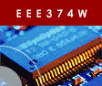 | Embedded Systems Course

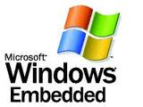
Laboratory Practical 1:
Oracle Virtual Box
&
Microsoft Windows Embedded

TEAM:  NOTE:  Short report to be written… see last page!! | Two
DURATION: | 2 hours
DOC REF: | Prac0.docx

1 Introduction 1
2 Starting out 1
3 Configuring and Creating an Windows Embedded Installation 2
3.1 Booting into Windows XP 2
3.2 Installing Windows Embedded Standard Tools (might be already done) 2
3.3 Create a new virtual machine 5
3.4 Booting Embedded Windows 7
4 Submission for this prac 8

Introduction

In this prac you will learn how to use a computer emulator (indeed a virtual computer) that runs on a regular PC. The emulator you will use is the Oracle VirtualBox, for which an open source version is available for both Linux and Windows (see: http://www.virtualbox.org/). An alternate emulator that you can choose to install on your own machine, or within a Virtual Box, is Microsoft’s own Virtual PC program (available at: http://www.microsoft.com/windows/virtual-pc). Please see Section 4 for details of what to submit for the completion of this prac.

Starting out

Start by logging in to Ubuntu if you haven’t already. The username and password are both bluelabuser. When you have logged in, opening a new Linux console on your computer and create a subdirectory in the home directory that is named according to your student number (e.g., STDNUM001) – commands to do this (as shown in Prac0) are given below:

cd ~
mkdir STDNUM001
cd STDNUM001

Use the STDNUM001 directory during this prac as a workspace to store files related to this prac.

NOTE: The home directory will be erased at the end of the prac. I recommend backing up your work to a flashdrive or on your own Vula “My Workspace” site.

Now for things to do…

Configuring and Creating an Windows Embedded Installation

Booting into Windows XP
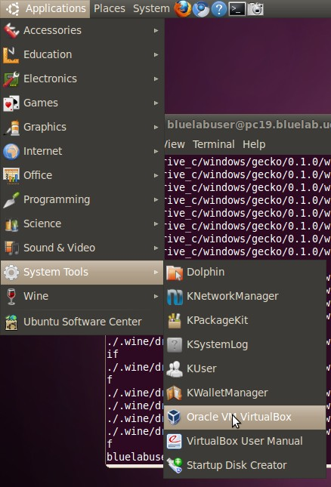
Start by running the Oracle VirtualBox application.

Do by selecting (see screenshot on right):

Applications Systems Tools
Oracle VM VirtualBox.

Note that the VitrualBox user manual is also located in the System Tools application folder.

This will open a window that shows you a selection of available VirtualBoxes (there’s probably just one at present). Choose the Windows XP virtual machine as directed by the tutor / lecturer.

This virtual machine will boot Windows XP. Essentially, you’ll be running Windows XP as a window in Ubuntu Linux. Most things you can do in Windows XP, you can do in that window, including accessing usb devices, serial ports, sound card, etc.

Installing Windows Embedded Standard Tools (might be already done)
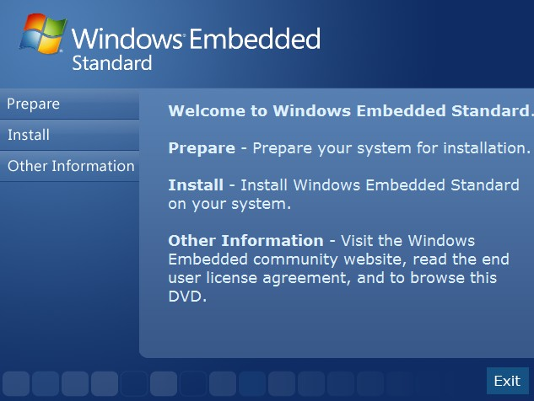
Click into the Windows XP window to change scope to XP.

Put your Windows Embedded 2009 DVD into your machine. The machine will probably think for a few minutes and then pop up the install program (see figure on right).

Click on the prepare tab on the left of the window and then install SQL Server Express-DVD (i.e., option 3 which installs the program from the DVD).

Agree to the licensing page, and let the installation proceed.

At this stage the program might delay things for a minute or so to do various scanning and configuration operations.

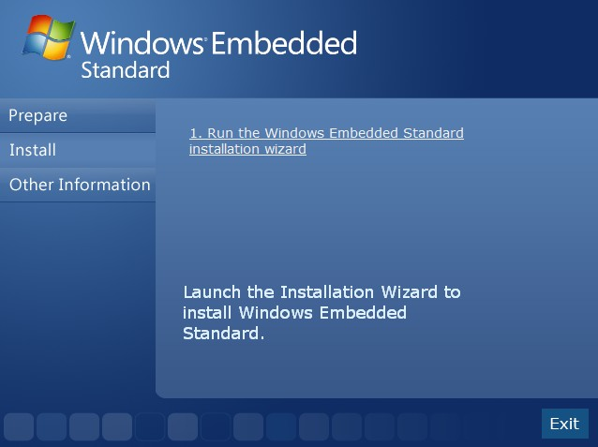
Once the SQL Server is installed, return to the install menu and click on the Install tab and proceed with installing Windows Embedded (see figure on right).

You’ll need to get an activation key before continuing...

Break out of the Windows XP virtual Box and return to Ubuntu (press right arrow and then control to do this).

Open the web browser and go to the following website:

www.windowsembedded.com/evalkey

On The page that loads, see the column with heading ‘(2) Get a product key’. In this column, find and click on the ‘Windows Embedded Standard 2009’ link.

You’ll probably need to sign up for a Windows Live ID. Before doing so, if you want to use your UCT email account, first sign into your email and add postmaster@windowslivemail.com as a contact so that an automatic email from that address is not blocked.

Now go back to the Windows Live ID registration. You’ll need to enter in an email address and a password. Then log in to your email and do as directed to validate the new login. Note that it may take a few minutes before the email arrives.

If you already have a Windows Live ID, sign in using your Windows Live ID username and password on the option on the right.
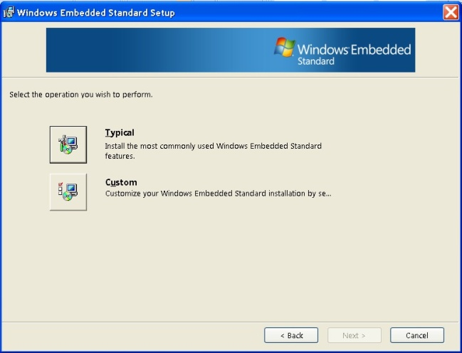
Once you have your license key, proceed with the installation by going back to the Windows XP session running in VirtualBox.

Enter in your key, accept the license agreement (checkbox at the top of the window) and press Next. You should not get a dialog as shown on the right:

Select the Custom option…

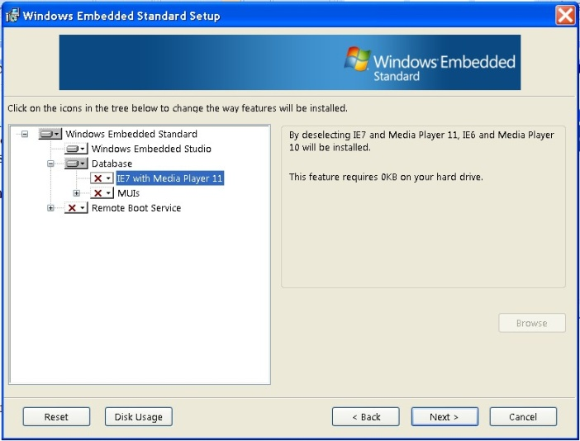
In the custom installation options, open the Database tree of options. Deselect IE7 with Media Player 11. (This option takes a lot of space and we won’t use it).

Click on Disk Usage. Make sure that there are no negative values in the ‘remaining’ column (i.e., that there is enough space, about 8GB in total available).

Click on the Next

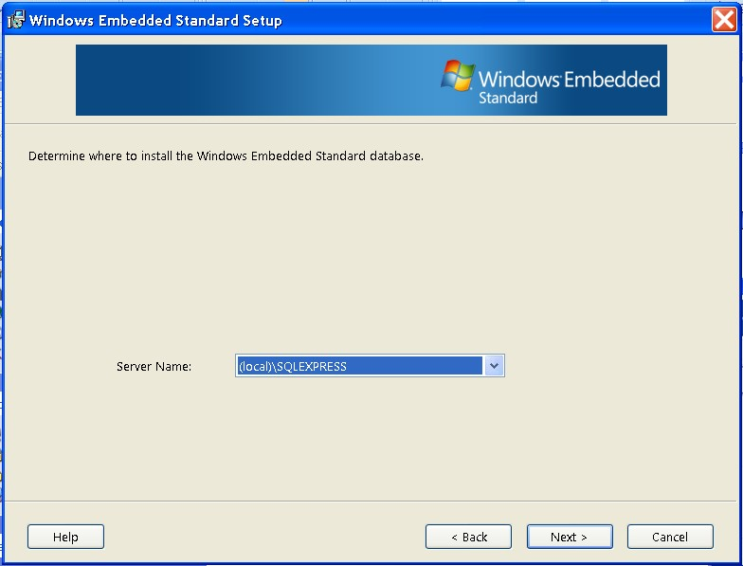
You should now get a display asking you to confirm the SQL server to use (there will probably just be one option, as shown on the right). Click Next and then Install to proceed with the installation.

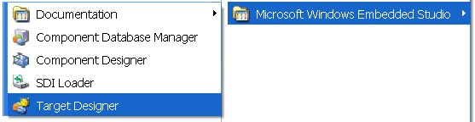
After a few minutes it should hopefully have installed successfully and you should now have a ‘Microsoft Windows Embedded Studio’ menu item in the start menu under ‘All Programs’.

Click on ‘Target Designer’ in the ‘Microsoft Windows Embedded Studio’ menu (see figure above).
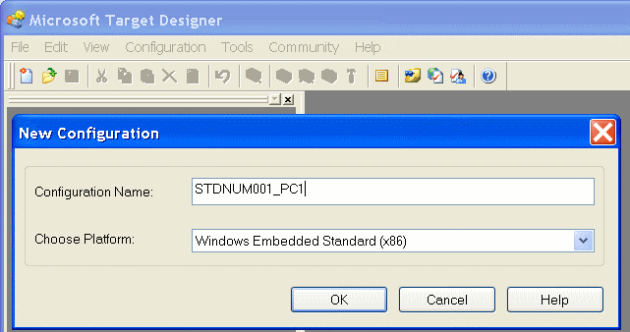
In Target Designer, click on New to create a new target design. Specify the name as STDNUM001_PC1 (where STDNUM001 is replaced by your student number). Click OK to continue.

A new target project will be created. You can fill out the Owner(s) and Author(s) details if you want to keep track of who created the project. Save the project in an appropriate directory (e.g. ~/STDNUM001) and use the default name.

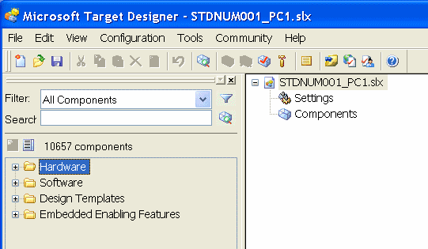
Now it’s a matter of choosing the components that you want to add to the Windows Embedded image. This is done using the panel on the left of the program window (see image on right). Open the Hardware tree and have a look at the hardware components that can be selected.

The hardware to choose should be the same devices as those that your workspace PC has. You can determine the drivers by going into Control Panel System Device Manager in Windows XP and select the appropriate driver in Target Designer.

In Computer add: Standard PC.
In Disk drivers: add a Disk drive.
In Display adapters: add an NVIDIA card as on your machine
In Monitors add: Super VGA 800x600
For mice and pointing devices: add Microsoft mouse (or whatever sort you have connected)
In Processors: add Intel Processor.
In System Services Base: add NT loader, and Session Manager (Windows subsystem)
Add a keyboard
Add the DVD drive
For Sound, video and game controllers: add Audio Codecs, Legacy audio drivers, and Media control devices.
For System Devices add what you can find in the device driver, including Direct Memory Access Controller, PCI bus, System board, System CMOS/real time clock, etc.

In Software System System Services Base: add FAT, and NTFS
In Software System International Infrastructure: Select English Language Support
In Software System Security Infrastructure: Select Windows Logon (Standard)

In Software System User Interface Shells Windows Shells: Select Task Manager
In Software System User Interface Shells Select Task Manager Shell

When you are done with adding component that you think are needed, save the project, and then select from the menu Configuration Check Dependencies.

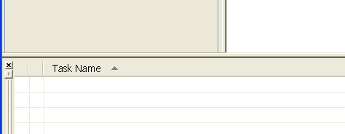
This operation will take a few seconds. If you end up with errors, look at the Tasks panel at the bottom of the screen. Move your mouse over the error listed to see what components you need to search for and add. When you’ve tried to address those errors, try the F5 / Check Dependencies option again.
Run mouse over this section to see suggestions for missing components.

Once there are no errors in the dependencies, select Configuration Build Target Image. Save to an appropriate directory that has at least 2GB free.
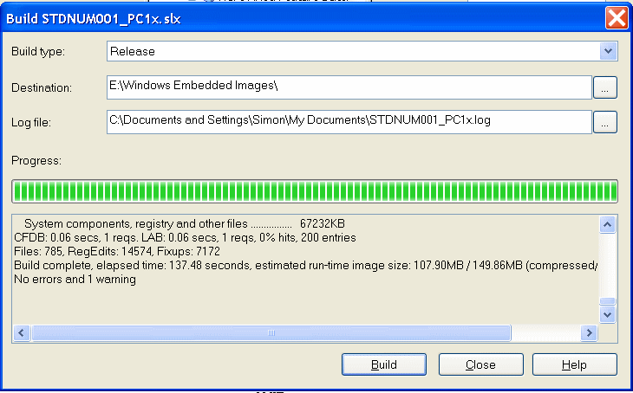
The build will probably take about a minute to complete. Ignore the final warning about a limited time run.

You can now go into the ‘Windows Embedded Images’ directory that it generated. These are the files that need to go into the boot disk ISO in order to boot Windows Embedded in a Virtual Box. Either an ISO can be made using a tool such as mkisofs, alternatively you can boot your virtual machine into WinPE (see the winpe_SP1_D1.iso in the download directory indicated on the assignment page). From WinPE you can then mount the Windows Embedded Images files and copy them over to the main virtual hard drive (if you want, you can then use the hd2iso tool located in the utilities directory under the Windows Embedded directory, where the executable for TargetDesigner resides). The steps to follow are as follows in the “Booting Windows Embedded” Section 3.4.

Create a new virtual machine

Let’s now create a new virtual machine. Returns to the Virtual Box control window.

- Click the NEW button to create a new machine.
- Specify the name of the machine as STDNUM001-WIN (where STDNUM001 is your student name).
- Select Windows XP as the operating system that the machine will run, and click Next.
- Choose a base memory of 256MB (you don’t need much memory to run Windows Embedded).
- Create a new virtual harddisk of 1GB (you don’t need much to harddrive space to run WE)
- Set the virtual harddisk to be ‘dynamically expanding storage’ (otherwise it wastes too much space).
- Use the default location for storing the harddrive, click Next and then Finish.
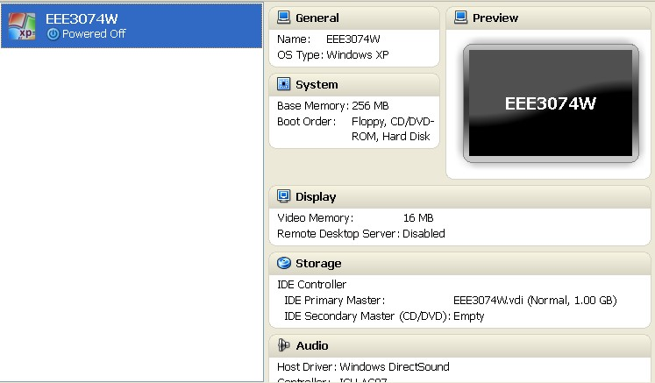
You should now see a display similar to
the one shown here:

Change the display setting (by double-clicking on the Display icon) as follows:

- Set the video memory to 8MB (this is enough to show graphics, but will keep the virtual box running more speedily than having to simulate a bigger display).

Don’t click OK yet…

Create a subdirectory in your STDNUM001 directory called “SHARE”, you can do this running the following commands in the Linux terminal that you probably still have open (change STDNUM001 as needed):

cd ~/STDNUM001
mkdir SHARE

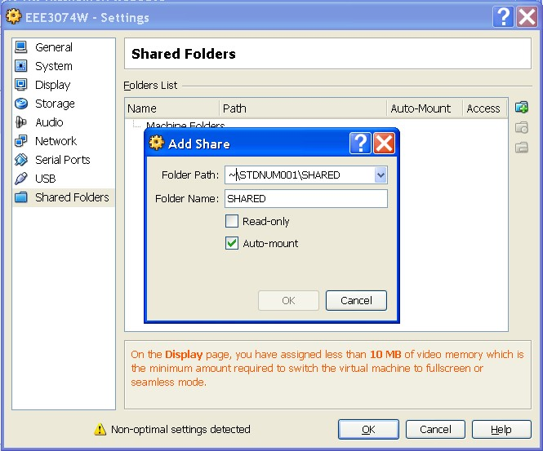
Now go back to the Settings window in the VirtualBox program. Select the Shared Folders and add a shared folder (click the folder icon with a ‘+’ on it) and the folder that you just created above (i.e., path ~/STDNUM001/SHARED). See screenshot:

Now click OK in the Settings dialog to save the changes.

Double click on the icon of your new virtual machine to ‘turn on its power’.

Click on the Devices Install Guest Additions
Reset the machine using Machine Reset

If you don’t install the Guest Additions, then it won’t be able to access CDs, USB, etc.

Take note of the ‘Host Key’ button (that might be needed to break out of the virtual machine). It’s probably set to ‘Right arrow, Control’.

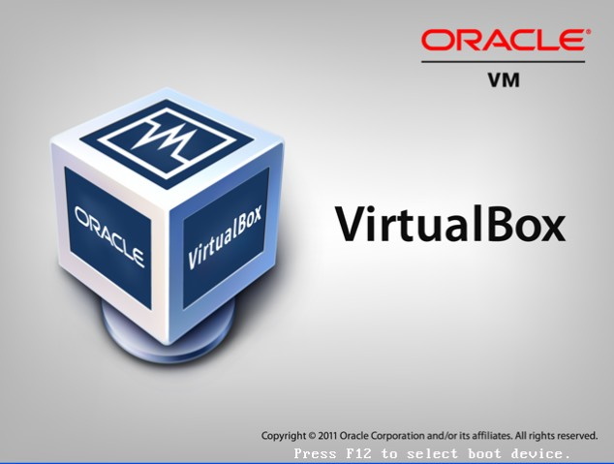
Now connect up the ISO created as a Virtual CD. And reboot. The splash screen for Virtual Box splash screen should display again (see figure on right).

Booting Embedded Windows

There are two ways to do this: option 1 involves copying the image to a virtual hard drive, and option2 involves creating an ISO. Note that the benefit of option 1 is that it allows you a read/write access for your installation, so you can install additional programs. The drawback of the ISO is that it is read only.

Option 1: Installation by copying from shared mount to virtual hardware

Start by mounting the Windows Embedded Image directory as a virtual drive in your virtual machine.
Then mount the WinPE (Windows Pre-install Environment) iso as a virtual CD in your Virtual machine. Reset the virtual machine and allow WinPE to boot. You can only use a command prompt in WinPE, use ‘cd’ to navigate the directory and ‘dir’ to list the files.

You need to edit the partitions (e.g. using DiskPar, add a partition, then format it). Create a C: partition to hold the Windows Embedded installation. Format C:\. Open the shared folder (from Windows Embedded Image) and copy the files over to C:\. Reset the virtual machine to boot Embedded Windows.

Alternatively, you can boot the virtual machine using a Linux Live CD or ISO and then use a tool like qtparted to configure the drives.

Further details can be found at: http://blog.augustoalvarez.com.ar/2009/04/26/windows-embedded-standard-2009-step-by-step-deployment-part-iii/

Option 2: Creating an ISO

At this stage you need to load an ISO building program to create the ISO file. Some programs to do this include:

- Mkisofs should already be installed in Ubuntu.
- Cdrtfe (front end for mkisofs for Windows)
- Create Burn ISO: www.brothersoft.com/free-create-burn-iso-download-60117.html (or download Createburniso.exe from Vula in Resources / Software).

When creating the ISO, make sure that you specify it is a bootable CD and indicate the boot loader (which goes into the first sectors of the CD).

The command for mkisofs can be used as follows:

mkisofs -b boot.img -no-emul-boot -boot-load-seg 1984 -boot-load-size 4 \
-iso-level 2 -J -joliet-long -l -D -relaxed-filenames -N -V WinXP -v -x .DS_Store -o ../WinXP.iso .

Page 4-50 of the Embedded Standard Training Manual provides further detail about booting (available from url: http://www.rrsg.uct.ac.za/courses/EEE3074W/SW/ ).

Submission for this prac

All students are not expected to complete this prac, as the process of configuring and setting up the boot ISO or harddrive setup is a tricky task. However, you need to answer the following things in the form of a short report:

- Now that you have some understanding of a Virtual Machine, such as Oracle Virtual Box, write few paragraphs (approx 200 words) explaining the merits of using a virtual machine in a development, especially embedded systems development, context.
- Explain how far you managed to get with the prac, at what point did you need to end off due to the time running out?
- If you didn’t get Windows Embedded to boot, what would be your next step?
- Discuss the merits and drawbacks of using Embedded Windows for an embedded systems project.

Submit your short report online using the Vula assignment for this prac.

end of assignment

